**Practical No. 12**

**Aim:** Develop Programs using BEFORE and AFTER Triggers, Row and Statement Triggers and INSTEAD OF Triggers

**Theory:**

Triggers are database objects that execute automatically in response to specific events or actions within the database. They are used to enforce business rules, audit changes, and perform other actions without requiring manual intervention. Triggers can be categorized based on when they execute (BEFORE or AFTER) and how they react to events (Row or Statement Triggers), and there are also INSTEAD OF Triggers, which allow you to customize behavior when data modification is requested.

**Queries:**

1) Trigger will display the salary difference between the old values and new values.

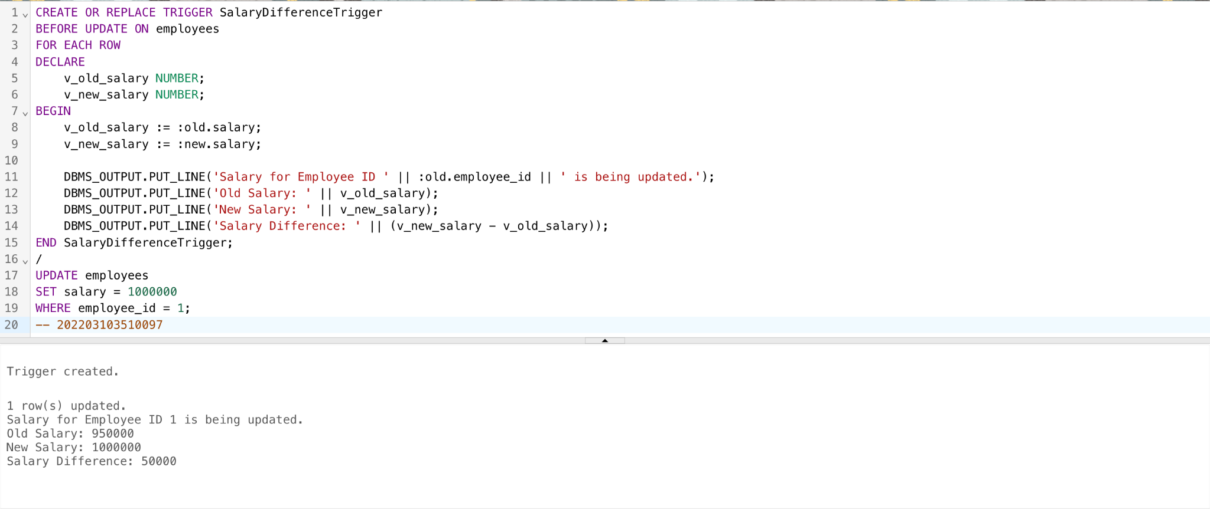

2) Stop the transaction if the quantity entered (insert) by the user exceeds 1000.

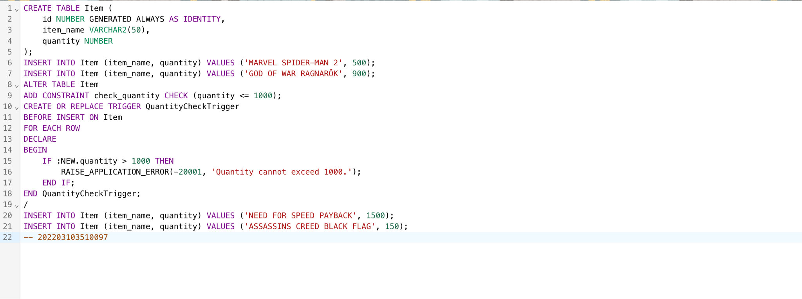

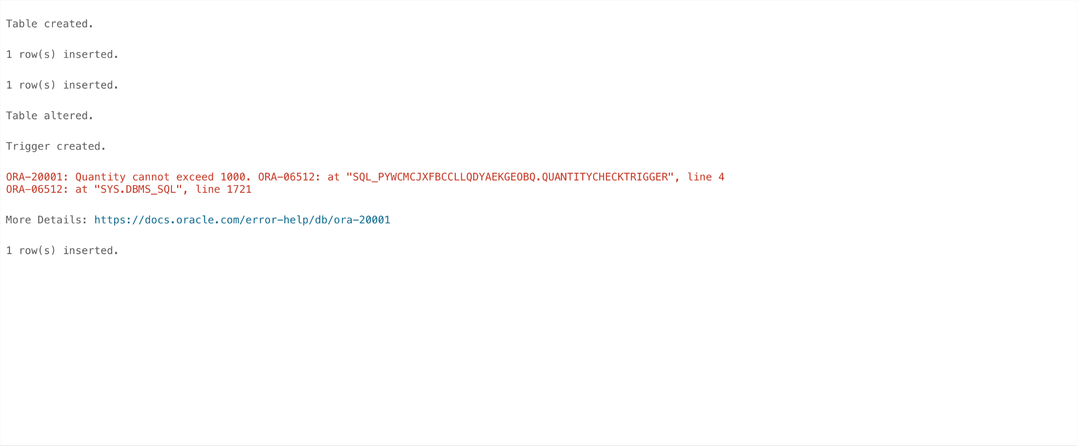

3) Maintain Log Table with use of trigger.

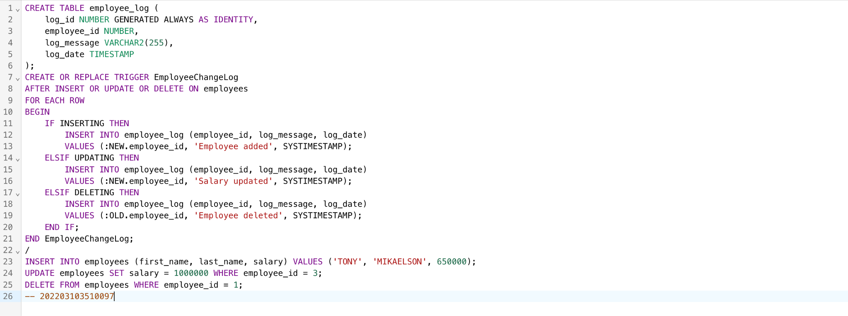

**Conclusion:** Triggers are essential tools in database management, enabling developers to automate actions, enforce data integrity, and customize behavior in response to database events. Understanding the different types of triggers (BEFORE, AFTER, Row, Statement, and INSTEAD OF) and their appropriate use cases is vital for effective database programming and management.